ARABIC
For Class IX (marks 75)
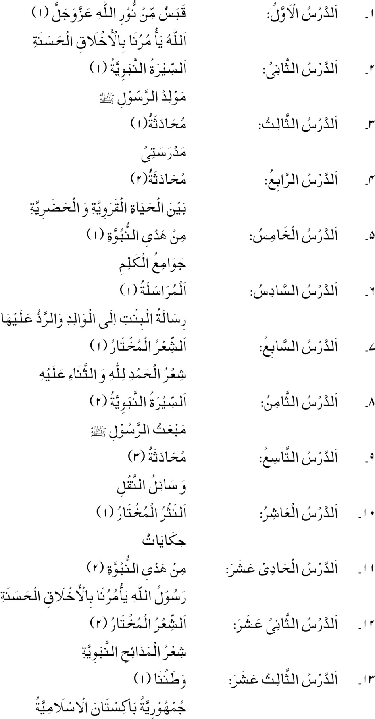

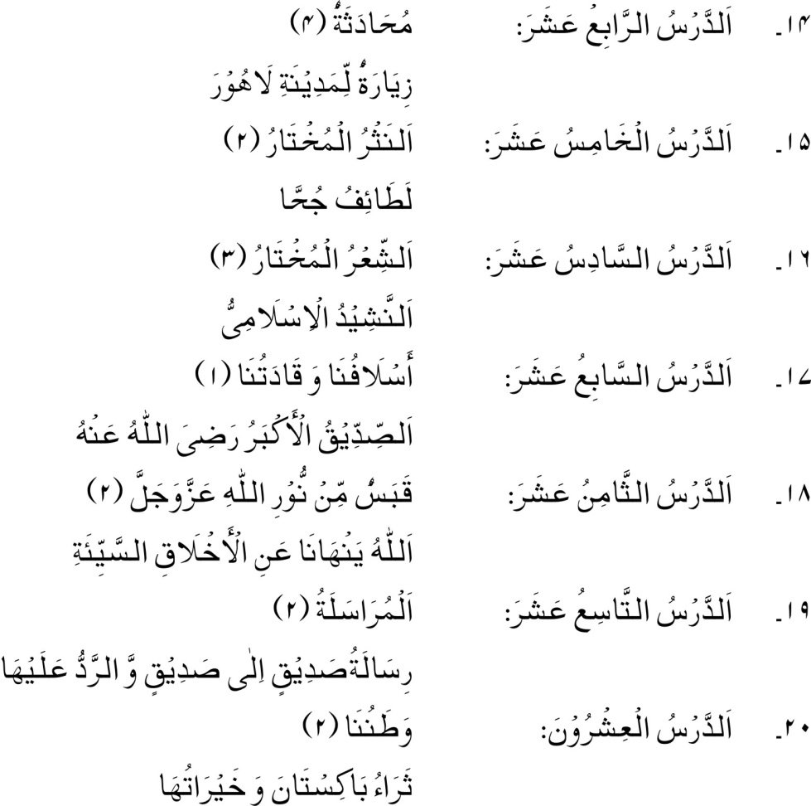

RECOMMENDED REFERENCE BOOKS FOR CLASS IX

The question paper will be syllabus oriented. However, the following books are recommended for reference and supplementary reading:
1.
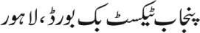
2.
3.
