CONTENTS OF PAKISTAN CULTURE SYLLABUS

I. Culture
A. Meaning, elements and scope
B. Concept of Islamic Culture

II. Pakistan: The land and the people
A: The Land
The Mountainous Zone: External Security and Cultural inflow; Northern Ranges and Southern Mountains
The Indus Basin: The Upper & Lower Basin, The River System – Early Civilizations
Arid Zones: Pastoral and Nomadic Life: The Plateaus and the Deserts, the Coastline: Maritime Links
B: The People
Racial Mix-Regional Traits, The Tribal System, Religious Groups, Occupational Groups, Urban-Rural Communities

III. The Making of Pakistan
A. Pre-Muslim Era: The Indus Valley Civilization Brahminic and Buddhist Traces
B. The Arab Period: Foundation of Islamic Society
C. Turco-Mughal Period: Turks and the Afghans, Resistance and Assimilation, The Sufis and their Role
The Mughals: Cultural Synthesis, Language, Arts and Architecture
D. Socio-Political Decline: Socio-Economic Set-backs
E. The Beginning Of Muslim Resurgence: Steps towards Socio-Economic Uplift, Struggle for Homeland, Sayyid Ahmad Khan, Muhammad Ali Jinnah (Quaid-i-Azam), The Birth of Pakistan

IV. Pakistan Culture
- Ideological Moorings (Islam): The Holy Quran and the Prophet Oneness of Allah- Tuahid, Prophethood-Risalat Knowledge-Ilm, Deeds-Amal, the Hereafter-Akhrat
- Social Patterns: Tribal, Feudal, Rural and Urban
- Arts and Crafts: Music: Vocal and Instrumental, Qirat and Hamd-o-Na’at, Painting, Calligraphy, Handicrafts and Folk Arts
- Education
- Language, Literature and Folklore: Urdu, Punjabi, Sindhi, Pashtu, Baluchi, Retrospect

V. Emerging Trends
New Orientations, Islamization, Education, Literature, Socio-Economic Trends

RECOMMENDED REFERENCE BOOKS

In contrast to the previous practice the examination will not be based on a single textbook, but will now be curriculum based to support the examination reforms. Therefore, the students and teachers are encouraged to widen their studies and teaching respectively to competitive textbooks and other available material.

Following books are recommended for reference and supplementary reading:

1. Pakistan Culture
Written by: Dr. M.H. Siddiqui,
Dr. Jamil Jalibi
Dr. Ansar Zahid Khan
Dr. Abdur Rehman
Published by: National Book Foundation, Islamabad

2. 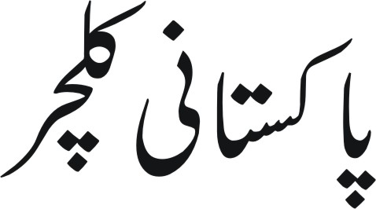
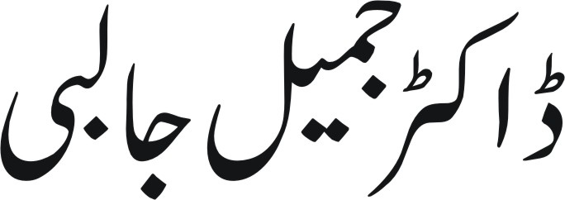
Published by: National Book Foundation, Islamabad

3. Pakistan Society and Culture
Compiled by: Lubna Saif
Javed Iqbal Syed
Published by: National Book Foundation, Islamabad

