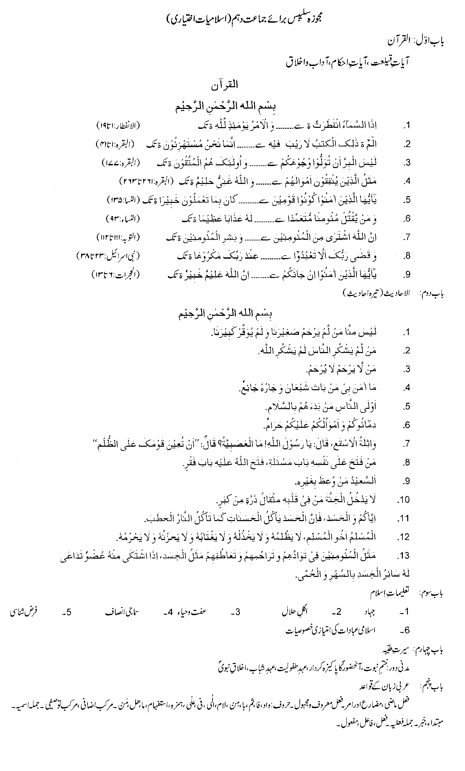
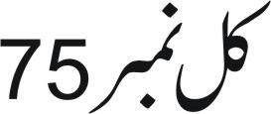

RECOMMENDED REFERENCE BOOKS FOR CLASS X

The question papers will be syllabus oriented. However, the following books are recommended for reference and supplementary reading:
1. Islamic Studies (Elective)
Punjab Textbook Board, Lahore
2. Islamic Studies
Baluchistan Textbook Board, Quetta

